Read the data set with read.csv function and split the data set into test and train sets. I assigned the first 100 data points to train set and the remaining 33 data point to the test set as described in the pdf.
Created the necessary data structures and put all training instances into the root node to start learning. To define pre-pruning I used the conditionwhere P is equals to 10 for the next question.
I used an algorithm similar to lab 07 code but with the following adjustments. Used node mean instead of node frequencies with the following notation
For our case we had no dimentionality so no iterations were needed over the dimensions so I removed the dimention operations. To calculate the split scores [s] I calculated the mean of y_train data for left indices and subtracted it from y_train for left indices and took the square of it finally I summed them up for each element.I did the same thing for right indices and summed it with left indices. This gave me the split score. My best score was when the split score was minimum and my best split was the position where my split score is minimum. I used the condition X_train[data_indices] <= best_splits to create left indices I choosed the edge case as above to get my scores as near as in pdf and similarly to create right indices I used X_train[data_indices] > best_splits condition. To calculate y_predicted I used a for loop similar to the one in lab 07 but since this is a regression proplem instead of using node frequencies and node features I employed once more the node mean that I defined previously.
To plot the graph in question 3 I employed the loop that I used to calculate y_predicted but instead of iterating over the data set size I iterated over the data_interval length that I defined previously this is a similar approach that we used in hw04 to plot graphs but in this case there were no bin widths. This gave me the fit line to plot in the graph. After plotting the red and blue dots I plotted the fir line which ended up as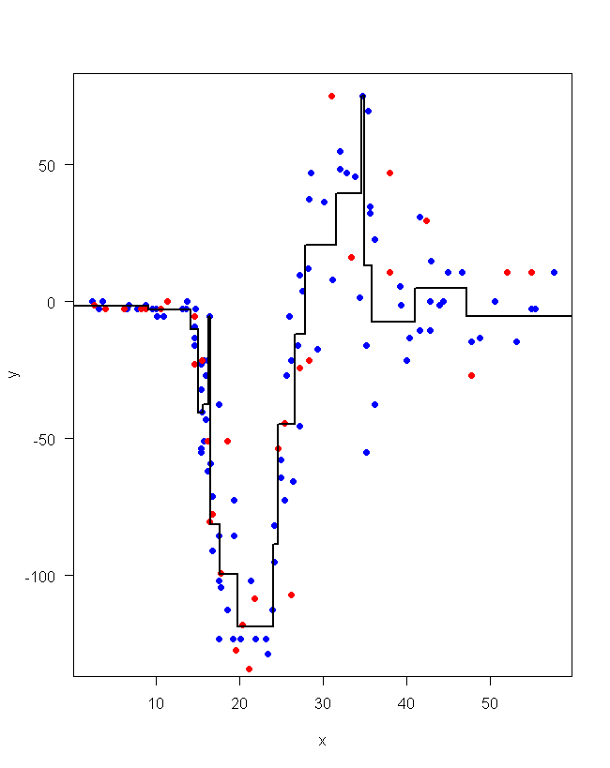.
To calculate RMSE I subtracted y_predicted that I calculated before with y_test value and got the square of it and diveded it with the test data size which is 33 in this case and used the sum function to do the operation. Finally got the sqrt of the value to calculate the rmse. The output was .
For the last question I used a for loop which starts from 1 and iterates to 20 which will be the P values of the learning algorithm. Each iteration creates the necessary data structures from scratch not to override the previous data. The loop contains the whole code of learning algorithm and the calculation of y_predicted at the end of each loop the rmse value for that iteration is recorded into RMSE_list. After the iteration I plot the RMSE values with connected lines and get the following graph.
